200 Massachusetts Ave, NW, Suite 700 P | 202-467-3750

Washington, DC 20001   www.dcbarfoundation.org F | 202-467-3753

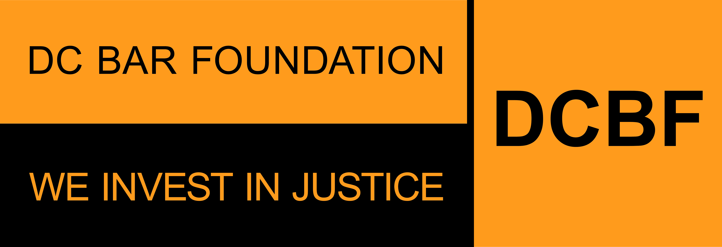

**Public and Private Grants Application Non-Legal Services Provider Organizations**

**Organization Profile Information**

**FY2025 Grant Program - Applications due by 11:59pm ET on Friday, August 30, 2024**

The **ORGANIZATION PROFILE INFORMATION** is required for an application. It describes the organization that is applying for DCBF funding. This is a description of your organization – not a description of your project/proposal.  
  
**Your Organization Profile information will be entered one time.** If you are applying for more than one grant, this information will be automatically included in all applications for the Access to Justice, Civil Legal Counsel Projects Program (CLCPP), and General Support grant programs.  
  
Before beginning the application, please read the program guidelines, application instructions, and award process information: <https://www.dcbarfoundation.org/grants>. Sample application forms are available via the specific grant program under the link.  
  
For technical assistance, refer to: [https://dcbarfoundation.org/grantee-portal/.](https://dcbarfoundation.org/grantee-portal/) If you have questions about the application or application process, please email [grants@dcbarfoundation.org.](mailto:grants@dcbarfoundation.org)

**Organization Information**

Address:

City / State / Zip Code:

Website URL:

**Physical Address Where Services Are Being Provided**

Is your physical address different from above? Y/N If Yes, provide your physical address.

**SAM.gov Registration Verification -** *In order to receive funds from DCBF, your organization/entity must maintain active registration with the federal System for Award Management (SAM). If you answer that your organization/entity has an active registration, you will be prompted to provide your Unique Entity ID. You are not required to have an active SAM registration in order to submit an application for funding; however, if your project is selected for funding, grant funds cannot be disbursed until DCBF has been able to confirm an active SAM registration. If you have any questions, please contact grants@dcbarfoundation.org.*

Is your organization's/entity's SAM Registration Status ACTIVE? Y/N

Enter your SAM Unique Entity ID. If your registration is INACTIVE or you have not received your ID, please leave the default value of zeros.

**Organization Budget Information**

Fiscal Start/End Dates:

Total Organizational Budget:

**Mission**

**Organization’s Mission**

What is your organization's mission statement?

What is your organization's experience in providing services to DC residents with low income or who are under-served?

What DC communities does your organization serve?

What do you see as the civil legal needs of the people you serve?

**Organization's Systems for Promoting Quality, Efficiency, and Effectiveness in the Delivery of Services**

In the last year, how did your organization use client feedback to improve its services?

Please describe your organization’s data collection, tracking, and evaluation methodologies including data collected at intake, timeframes, type of data collected, frequency of data collection, staffing, and technology related to these efforts.

The DC Bar Foundation is committed to infusing racial justice and equity in our work, and we are committed to evolving our practice and culture to learn, reflect, unlearn and change our practices in the pursuit of justice. Please use the space below to describe how your organization is integrating racial equity into your organizational culture as well as services associated with this proposal.

Explain any capacity building needs that would help you reach your organizational and programmatic goals during the grant year.

**Executive/Board Information**

**Executive/Board Information**

Prefix: First Name: Last Name: Job Title: Email: Office Phone Number: Extension:

**Board Chair Information** - *If you are awarded a grant, you will receive your grant agreement via DocuSign. To streamline the grant agreement process, please provide the name and email address of the Board Chair as of January 1 of the upcoming year-- that is, the first day of the term for all new grant agreements.*

Board Chair First Name: Board Chair Last Name: Board Chair Email:

**Attachments** – the following documents will be uploaded with your application:

**Nonprofit Status**

The organization’s Internal Revenue Service ruling letter regarding applicant’s tax-exempt status. Upload as a PDF.

**Organizational Budget**

The organization’s current annual organizational budget. Upload as a PDF.

**Form 990**

The organization's most recent Form 990 and schedules. Upload as a PDF.

**Audited Financial Statements**

Provide the organization's most recent audited financials. Upload as a PDF.

**Client Eligibility Guidelines on Residency and Income**

Download the document via the DCBF website under this link: <https://www.dcbarfoundation.org/grant-programs>.

Upload the completed document as a PDF

**Explanation or Notes on the Financials (OPTIONAL)**

Upload as a PDF.

**Demographic Survey**

**Demographic Survey Board Members and Staff**

Number of board members:

Number of executive/management staff:

Number of supervising staff:

Number of line staff:

Number of administrative staff:

**Demographic Survey Tables Data Collection**

*You will enter Board Member and Staffing details by gender, race, and ethnicity via an online form in the grants management system.*

Enter Board Members and Staff by Gender Details

Number of board members:

Number of executive/management staff:

Number of supervising staff:

Number of line staff:

Number of administrative staff:

Total number of board members:

Total number of staff

Enter Board Members and Staff by Race Details

Number of board members:

Number of executive/management staff:

Number of supervising staff:

Number of line staff:

Number of administrative staff:

Total number of board members:

Total number of staff:

Enter Board Members and Staff by Ethnicity Details

Number of board members:

Number of executive/management staff:

Number of supervising staff:

Number of line staff:

Number of administrative staff:

Total number of board members:

Total number of staff: