200 Massachusetts Ave, NW, Suite 700 P | 202-467-3750

Washington, DC 20001   www.dcbarfoundation.org F | 202-467-3753

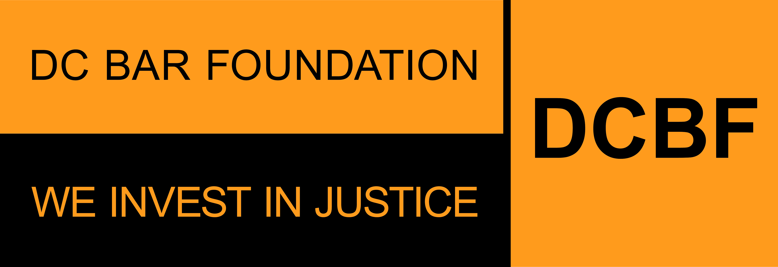

**FY2025 Access to Justice Grants Program**

**Shared Legal Services Interpreter Bank**

**APPLICATION SAMPLE FORM**

**Applications due by 11:59pm ET on Friday, August 30, 2024**

Before beginning the application, please read the program guidelines, application instructions, and award process information: <https://www.dcbarfoundation.org/grants>. Sample application forms are available via the specific grant program under the link.  
  
For technical assistance, refer to: [https://dcbarfoundation.org/grantee-portal/.](https://dcbarfoundation.org/grantee-portal/) If you have questions about the application or application process, please email [grants@dcbarfoundation.org.](mailto:grants@dcbarfoundation.org)

**Applicant Information**

Organization Information: Name; Address

Applicant Information: Name; Phone; Email

**Executive Summary**

Please provide info for the most senior legal staff member working directly on the project: First Name; Last Name; Email; Job Title

Project Name:

Grant Category: Shared Legal Services Interpreter Bank

In one or two sentences, provide a short description of this project.

**Budget & Funding**

Funding Request: *(For the period January 1 – December 31)*

Total Project Budget: *(For the period January 1 – December 31)*

Percent of Project Request to Be Funded by DCBF: *(auto-calculated)*

Total number of attorney full-time equivalents (FTEs) to be covered by the requested DCBF funds:

Total number of attorney FTEs that are or will be working on this project under the total project budget:

If you entered zero as the total number of attorney FTEs that are or will be working on this specific project under the total project budget, please provide an explanation as to why no attorney FTEs will be working on this project under the total project budget.

**Application Narrative**

*(Please limit your responses to each question to 500 words or less.)*

## Need and Project Description

Has the need for language access services changed over the last year? If so, please explain in what ways it has changed

Provide a description of your request. Make sure to include how your project and organization seek to address the need(s) or issue(s) referenced above.

**Outreach**

How does the project that would be supported with the requested grant conduct outreach to engage DC residents with low income or under-served who would benefit from your services? Please include how your organization engages with external institutions for outreach, if applicable.

**Impact**

What outcomes do you expect from the services that would be funded under this grant? Instead of thinking about how many people received services, think about what will happen as a result of the service you are providing.

**Proposed Performance Measures**

*Please read the standard and criterion below and provide estimates for each criterion for the grant period (January 1-December 31). Only provide the performance measures that will be covered by the ATJ funds. For example, if you request that 30% of the project be covered by ATJ funds and 70% of it will be covered by other funds, and you plan to accept 100 cases for brief advice, 30 of those cases would be funded through ATJ, and you would use this number for your performance measures. The remaining 70 cases would be covered by other funds, and you would not include these in this proposal. If your proposal is approved, these will become your performance measures for the grant period, and you will report progress on these goals to DCBF semiannually. Definitions for many of these terms are included in the section on performance measures in the Program Overview and Application Instructions. Please limit your responses to 500 words or less.*

**Performance Measures for Volume and Scope of Services**

Number of legal aid providers you plan to provide with interpreter and/or translation services:

Number of DC residents with low incomes or under-served you plan to provide with interpretation and translation services:

Number of documents you plan to translate:

Number of languages for which you plan to provide translation:

List top three languages for which you plan to provide translation.

**Performance Measures for Increasing Accessibility to Legal Services**

*Estimate the number of DC residents with low income or under-served who will receive services from each ward.*

*Note: The sum of the values entered in this section should equal the value you entered for the question: Total number of DC residents with low income or under-served who will receive direct legal assistance (includes advice, brief service, extended representation) through this project.*

***Residents Served by Ward Break Down***

Ward 1: Ward 2: Ward 3: Ward 4: Ward 5:

Ward 6: Ward 7: Ward 8: Homeless or Ward Unknown:

Total of Residents Served by Ward:

**Performance Measures for Outreach and Training**

Number of DC organizations that you plan to inform about your services:

Short description for local information sharing.

Number of regional and national organizations that you plan to inform about your services:

Short description for regional and national information sharing.

**Attachments** – the following documents will be uploaded with your application:

**Data Packet**

Download the document via the DCBF website under this link: <https://www.dcbarfoundation.org/atj-grants>.

Upload the completed document as an Excel file.

**Budget Explanation Notes**

Download the document via the DCBF website under this link: <https://www.dcbarfoundation.org/atj-grants>.

Upload the completed document as a PDF file.

**Supporting Documentation**

Upload as a PDFfile.

**Resumes**

Current resumes of all staff and supervisory personnel who will be involved in the activity for which funding is sought. If any positions are currently vacant, include the position’s job descriptions. Please upload each resume as a separate PDF file and include the project staff person's name in the file name. If you are uploading a position description include the position title in the file name.

**Signatures**

In the grants management system, click the Submit – Pending Signature button to submit the completed application for e-signature by the persons listed as Executive Director and Board Chair in your Organization Profile.

**Signature:**

Executive Director/President/CEO

Board Chair/President