200 Massachusetts Ave, NW, Suite 700 P | 202-467-3750

Washington, DC 20001   www.dcbarfoundation.org F | 202-467-3753

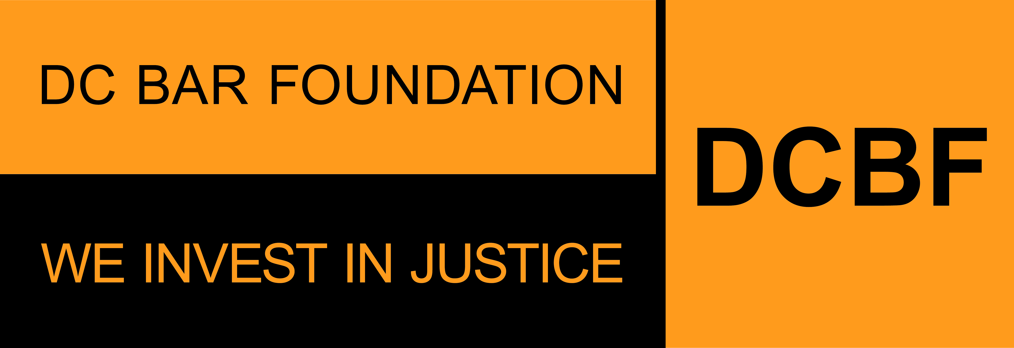

**Public and Private Grants**

**BUDGET EXPLANATION NOTES**

**BUDGET NARRATIVE**

Organization Name:

Project Title (if applicable):

**Personnel Cost:**  
Example: *The total budget for personnel salaries is $140,000 from the organization’s requested funds for this grant. Based on historical data, we estimate a fringe rate of 5%. Three (3) attorneys will be working on cases under this program at an annual salary of $100,000. Attorney A is estimated to spend 50% of their time to this program, with Attorney B at 20% and Attorney C at 30%. The non-attorney staff on this project will be one (1) full-time employee on this program at a salary of $40,000.*

**Non-Personnel Costs:**  
**Consulting/Professional Services:**

Instructions: *Describe the services to be provided. If this project received DCBF funding the previous grant cycle, describe any changes in expenses from FY23 to those requested for FY24.*

Example: *The overall consultant expense is projected to increase by roughly $5,000, from $15,000 in FY23 to $20,000 in FY24. This increase is due in large part to specialized expertise needed for training, evaluation, capacity building, and program implementation for this CLCPP project. The FY24 budget includes funding for continued work with ABC Corporation to conduct a second evaluation of the existing civil legal aid network.*

**Dues and Fees:**  
Example: *The subscription to ABC is to support the CLCPP network communication with all subgrantees/Clients estimated an annual fee of $3100.*

**Other Costs:**  
Example: *Other costs include subscriptions to software like Microsoft Office, Hootsuite, and Adobe, as well as office supplies ordered from Amazon, etc.*