200 Massachusetts Ave, NW, Suite 700 P | 202-467-3750

Washington, DC 20001   www.dcbarfoundation.org F | 202-467-3753

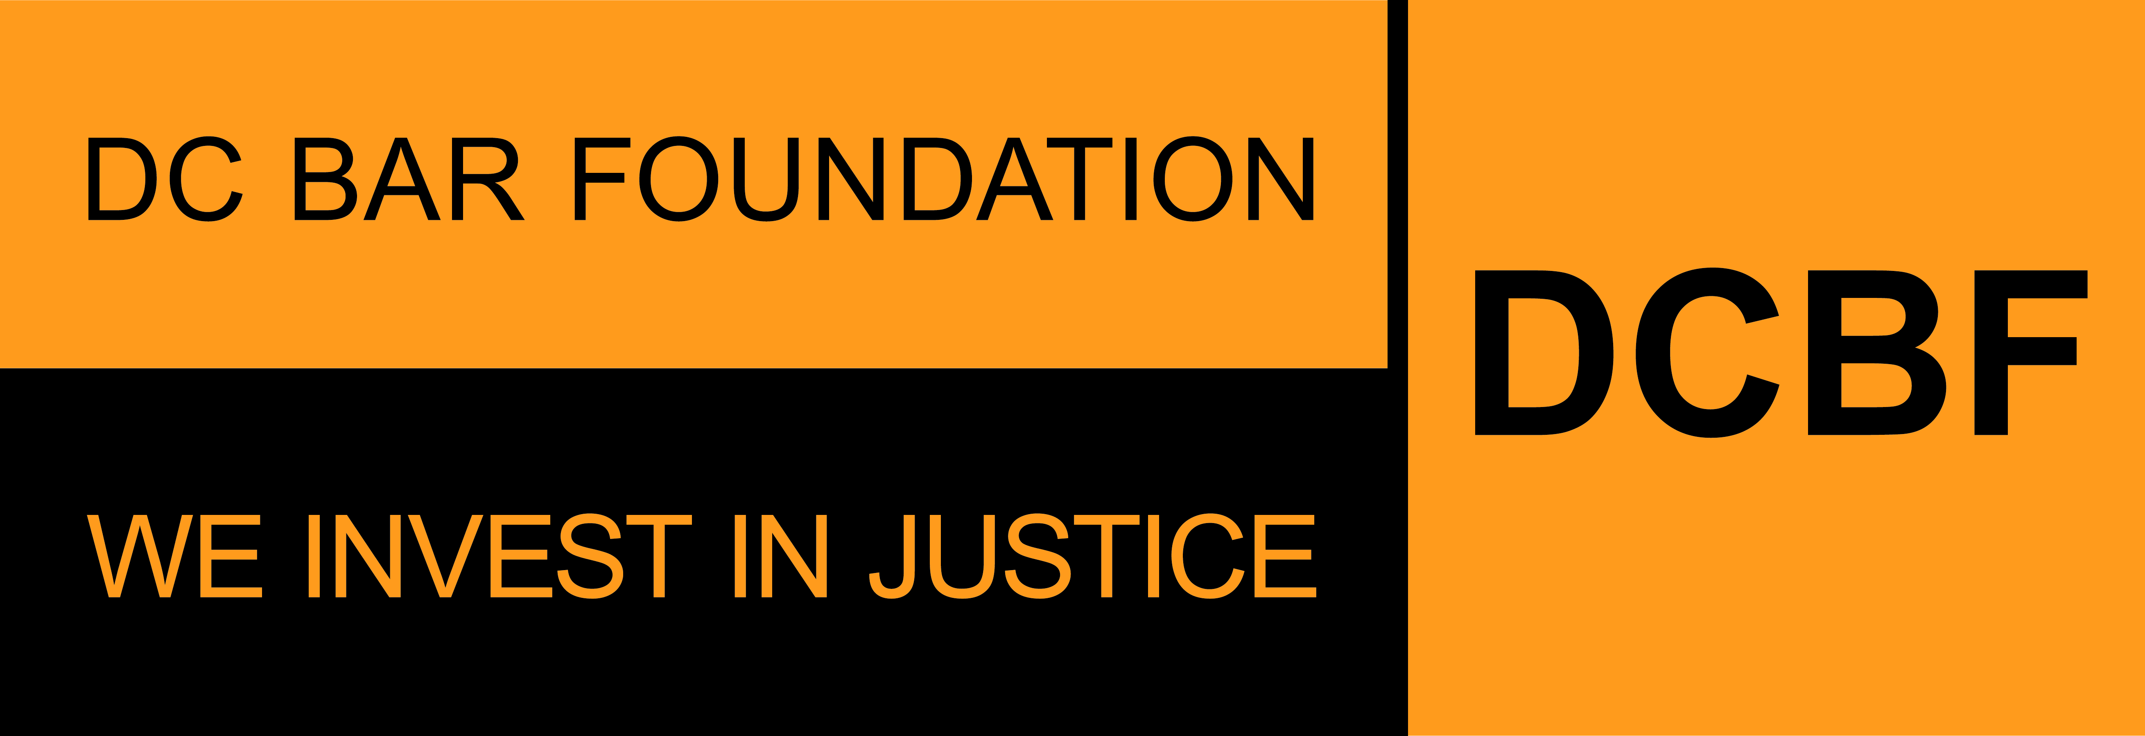

**FY2025 Access to Justice Grants Program**

**Legal Services Provider Organizations**

**APPLICATION SAMPLE FORM**

**Applications due by 11:59pm ET on Friday, August 30, 2024**

Before beginning the application, please read the program guidelines, application instructions, and award process information: <https://www.dcbarfoundation.org/grants>. Sample application forms are available via the specific grant program under the link.  
  
For technical assistance, refer to: [https://dcbarfoundation.org/grantee-portal/.](https://dcbarfoundation.org/grantee-portal/) If you have questions about the application or application process, please email [grants@dcbarfoundation.org.](mailto:grants@dcbarfoundation.org)

**Applicant Information**

Organization Information: Name; Address

Applicant Information: Name; Phone; Email

**Executive Summary**

Please provide info for the most senior legal staff member working directly on the project: First Name; Last Name; Email; Job Title

Project Name:

Grant Category: *(This application is only for “Housing-Related Matters” and “Underserved Areas” categories.)*

Specific Group(s) or Targeted Populations(s) served*: Children; Elderly; Immigrants; LGBTQ+; Returning Citizens; Not Applicable; All of the Above; Other (if “Other”, please specify.)*

In one or two sentences, provide a short description of this project.

Are you applying for a joint project with other organization(s), working towards the same outcomes but each applying for a separate grant award? Yes / No *If “Yes”, specify the organization(s).*

Is this a joint application with a nonprofit that does not provide legal services?

(Please note that a MOU will be required if this grant is awarded.) Yes / No *(If “Yes”, specify the collaborating organization.*

***If this is a joint application with a nonprofit that does not provide legal services:*** *The Project Name for this application needs to be the same as the project name for your collaborating organization. Please coordinate with your collaborating organization to ensure both applications use the same Project Name. You can edit the Project Name in the grants management system any time PRIOR to when you submit the application.*

**Budget & Funding**

Funding Request: *(For the period January 1 – December 31)*

Total Project Budget: (*Should reflect organization’s portion of the project budget.)*

Percent of Project Request to Be Funded by DCBF: *(auto-calculated)*

Total number of attorney full-time equivalents (FTEs) to be covered by the requested DCBF funds:

Total number of attorney FTEs that are or will be working on this project under the total project budget:

**Application Narrative**

*(Please limit your responses to each question to 500 words or less.)*

## Need and Project Description

Explain the need(s) or issue(s) to be addressed. Make sure to include relevant data and statistics that highlight the need(s) or issue(s), specific to the geography or community served.

Provide a description of your request. Make sure to include how your project and organization seek to address the need(s) or issue(s) referenced above.

Explain how your project aligns with DCBF priorities.

For returning applicants, if you are requesting more than a 10% increase in funding over last year’s award, please explain the increased need for funding (for example, an increase in services and outcomes, increased time spent per case, salary increases, project expansion, etc.)

**Outreach**

How does the project that would be supported with the requested grant conduct outreach to engage DC residents who are with low income or under-served who would benefit from your services? Please include how your organization engages with external institutions for outreach, if applicable.

**Impact**

What outcomes do you expect from the services to be provided through this project? Instead of thinking about how many people received services, think about what will happen as a result of the service you are providing.

**Proposed Performance Measures**

*Please read the standard and criterion below and provide estimates for each criterion for the grant period (January 1-December 31). Only provide the performance measures that will be covered by the ATJ funds. For example, if you request that 30% of the project be covered by ATJ funds and 70% of it will be covered by other funds, and you plan to accept 100 cases for brief advice, 30 of those cases would be funded through ATJ, and you would use this number for your performance measures. The remaining 70 cases would be covered by other funds, and you would not include these in this proposal. If your proposal is approved, these will become your performance measures for the grant period, and you will report progress on these goals to DCBF semiannually. Definitions for many of these terms are included in the section on performance measures in the Program Overview and Application Instructions. Please limit your responses to 500 words or less.*

Total number of DC residents with low income or under-served who will receive direct legal assistance (includes advice, brief service, extended representation) through this project.

*Definitions of these types of legal services are available in the Program Overview and Application Instructions.*

**Performance Measures for Legal Services Provided to DC Residents With Low Income Or Under-Served**

Number of DC cases that will be accepted for advice or legal counsel only.

Short description of advice or legal counsel cases that may be accepted.

Number of DC cases that will be accepted for brief service only.

Short description of brief service cases that may be accepted.

Number of DC cases that will be accepted for extended representation only.

Short description of extended representation cases that may be accepted.

Number of DC cases that will be accepted for systemic work only.

Short description of systemic cases that may be accepted.

Total number of DC cases.

**Performance Measures for Increasing Accessibility to Legal Services**

*Estimate the number of DC residents with low income or under-served who will receive services from each ward.*

*The sum of the values entered in this section should equal the value you entered for the question: Total number of DC residents with low income or under-served who will receive direct legal assistance (includes advice, brief service, extended representation) through this project.*

Residents Served by Ward Break Down

Ward 1: Ward 2: Ward 3: Ward 4: Ward 5:

Ward 6: Ward 7: Ward 8: Homeless or Ward Unknown:

Total of Residents Served by Ward:

Language Access: Provide the number of DC residents with low income or under-served to be served with limited or no proficiency in Spoken English, if applicable.

**Performance Measures for Outreach and Training**

*Provide an estimate for the performance measure relating to pre-court intervention below. Enter "0" if you do not plan on incorporating that type of outreach or training with this funding into your project during the grant period. Definitions are available in the Program Overview and Application Instructions*.

The number of educational events to be held, including Know Your Rights trainings, for DC residents with low income or under-served.

Short description of the community education events to be held*. Include frequency for each training in bullet/list format. Enter “N/A” if you do not plan on holding any community legal education events.*

List potential subject matters to be covered during those trainings.

The number of trainings for other DC organizations. *Provide the number of trainings that will be conducted by this project for other DC legal services providers and/or other DC organizations during the grant period.*

List potential subject matters to be covered during those trainings.

**Performance Measures for Pro Bono Development**

Estimate the number of pro bono attorneys this project will train during the grant period.

Estimate the number of cases that will be placed or co-counseled with pro bono attorneys.

If you do not use pro bono, please explain why not.

**Attachments** – the following documents will be uploaded with your application:

**Data Packet**

Download the document via the DCBF website under this link: <https://www.dcbarfoundation.org/atj-grants>.

Upload the completed document as an Excel file.

**Budget Explanation Notes**

Download the document via the DCBF website under this link: <https://www.dcbarfoundation.org/atj-grants>.

Upload the completed document as a PDF file.

**Supporting Documentation**

Upload as a PDFfile.

**Resumes**

Current resumes of all staff and supervisory personnel who will be involved in the activity for which funding is sought. If any positions are currently vacant, include the position’s job descriptions. Please upload each resume as a separate PDF file and include the project staff person's name in the file name. If you are uploading a position description include the position title in the file name.

**Signatures**

In the grants management system, click the Submit – Pending Signature button to submit the completed application for e-signature by the persons listed as Executive Director and Board Chair in your Organization Profile.

**Signature:**

Executive Director/President/CEO

Board Chair/President