200 Massachusetts Ave, NW, Suite 700 P | 202-467-3750

Washington, DC 20001   www.dcbarfoundation.org F | 202-467-3753

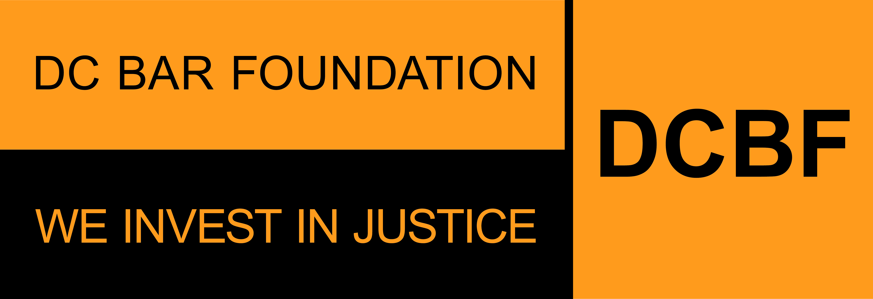

**FY2025 Civil Legal Counsel Projects Program**

**Non-Legal Services Provider Organizations**

**APPLICATION SAMPLE FORM**

**Applications due by 11:59pm ET on Friday, August 30, 2024**

Before beginning the application, please read the program guidelines, application instructions, and award process information: <https://www.dcbarfoundation.org/grants>. Sample application forms are available via the specific grant program under the link.  
  
For technical assistance, refer to: [https://dcbarfoundation.org/grantee-portal/.](https://dcbarfoundation.org/grantee-portal/) If you have questions about the application or application process, please email [grants@dcbarfoundation.org.](mailto:grants@dcbarfoundation.org)

**Applicant Information**

Organization Information: Name; Address

Applicant Information: Name; Phone; Email

**Executive Summary**

Please provide info for the most senior staff member working directly on the project: First Name; Last Name; Email; Job Title

Project Name: *The Project Name should be the same name for this application and the application submitted by the legal services provider you are partnering with on this application. Please coordinate with the legal services provider to ensure both applications use the same Project Name. You can edit the Project Name any time PRIOR to when you SUBMIT the application.*

Grant Category: *Eviction – Related Proceedings*

Specific Group(s) or Targeted Populations(s) served by this project for which you are seeking funding*:* [General Low-Income Population], [Households with Children], [Individuals with Housing Subsidies], [People who are illiterate or have low literacy], [People with limited English proficiency], [Returning Citizens (Formerly Incarcerated Individuals)], [Residents of affordable housing units slated for conversion], [Seniors 60 and over], [Veterans], [Victims of domestic violence], [Victims of housing discrimination], [Other, please specify: _________)

In one or two sentences, provide a short description of this project.

**Budget & Funding**

Funding Request: *(Amount requested for the services proposed by your organization for the period January 1 – December 31)*

**Application Narrative**

*(Please limit your responses to each question to 500 words or less.)*

Please name the legal services provider you are partnering with on this project. (Please note that a MOU will be required if this grant is awarded.)

Have you and the legal services provider previously partnered? If so, for how long? Please briefly describe the prior partnership.

Please provide a description of the project that includes the services you will provide and how those services support the legal services provider, the project, and the proposed legal services outcomes. Describe organizational capacity to deliver the project. Include examples and/or brief case stories.

List the top 3 measurable outputs and outcomes you propose to meet through this project. For example, number of outreach touchpoints, number of referrals, etc.

**Attachments** – the following documents will be uploaded with your application:

**Data Packet**

Download the document via the DCBF website under this link: [https://www.dcbarfoundation.org/civil-legal-counsel-grants.](https://www.dcbarfoundation.org/civil-legal-counsel-grants)

Upload the completed document as an Excel file.

**Data and Information Collection Requirements Attachment**

*The data collection requirements of the Civil Legal Counsel Projects Program are significant and evolving, as they involve both statutorily required data and comprehensive programmatic data for the purpose of our ongoing evaluation. As noted in the Data and Information Collection Requirements Attachment, participants in this program commit to providing all requested data, including some data points that may not yet be established.* Please review the current data collection requirements available via the DCBF website under this link: <https://www.dcbarfoundation.org/civil-legal-counsel-grants>

Please sign and upload as a PDF file.

**Budget Explanation Notes**

Download the document via the DCBF website under this link: <https://www.dcbarfoundation.org/civil-legal-counsel-grants>

Upload the completed document as a PDF file.

**Supporting Documentation**

Upload as a PDF file.

**Resumes**

Current resumes of all staff and supervisory personnel who will be involved in the activity for which funding is sought. If any positions are currently vacant, include the position’s job descriptions. Please upload each resume as a separate PDF file and include the project staff person's name in the file name. If you are uploading a position description include the position title in the file name.

**Signatures**

In the grants management system, click the Submit – Pending Signature button to submit the completed application for e-signature by the persons listed as Executive Director and Board Chair in your Organization Profile.

**Signature:**

Executive Director/President/CEO

Board Chair/President